# Supramolecular Approaches to Functional Cocrystal Design

## Ranjit Thakuria

### 1Department of Chemistry, Gauhati University, Guwahati, Assam, India 2 Ulam NAWA fellow, Faculty of Chemistry, University of Warsaw, Warsaw 02-093, Poland

### ranjit.thakuria@gauhati.ac.in

Supramolecular interactions such as hydrogen bonding, halogen bonding and π–π stacking interactions play a vital role in the field of Crystal Engineering, which focuses on the rational design and assembly of molecular solids through non-covalent forces. Unlike covalent modifications, supramolecular approaches allow the modulation of material properties without altering the intrinsic structure of the molecular components. The utilization of supramolecular synthons have made it possible to design multicomponent crystalline systems with desired properties. Here in my talk, I will discuss about our work related to agro-based cocrystal design1,2 as a sustained release fertilizer, preparation of pharmaceutical multi-component solids as well as organic fluorophore3-5 in order to tune various materials properties (Figure 1).

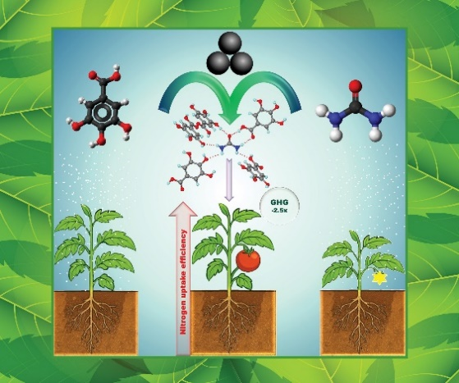 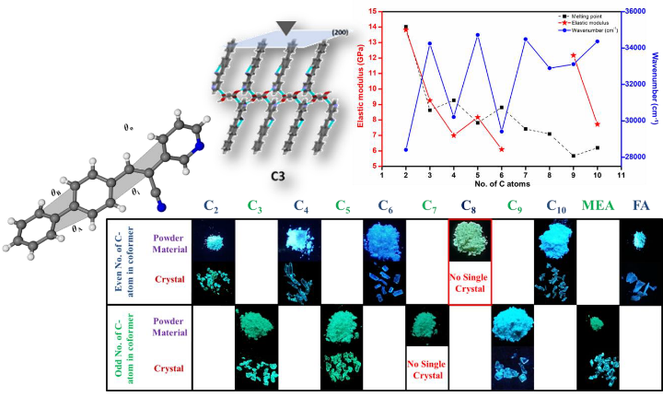

###### **Figure 1**. Application of mechanochemistry in agro-based cocrystal and materials design.

#### [1] Parakatawella, S., Gogoi, D., Deka, P., Xu, Y., Sandaruwan, C., Jayasundera, A.C., Arhangelskis, M., Thakuria, R. & Adassooriya, N.M., (2022). *ChemSusChem*., **15**, e202102445

#### [2] Madanayake, N. H., Gogoi, D., Jayasuriya. G. K. M. G., Perera, A. T. D., Thakuria, R. & Adassooriya, N. M. (2025). *ACS Sustain. Chem. Eng.*, **13**, 9481.

#### [3] Deka, P., Das, S., Sarma, P., Kalita, K. J., Vijayaraghavan, R. K., Reddy, C. M. & Thakuria, R.(2024). *Cryst. Growth Des.,* **24**, 2322.

#### [4] Kalita, N., Kalita, K. J., Borah, S. S., Puschmann, H., Nath, N. K. & Thakuria, R. (2025). *ACS Appl. Opt. Mater*, **3**, 1078.

[5] Kalita, N., Deka, P., Ghosh, I., Kalita, K. J., Gogoi, A., Reddy, C. M. & Thakuria. R. (2025). *J. Mater. Chem. C*, **13**, 10769.